**Question 1**

Create a sample table in postgres/mysql with following columns **(15 Marks)**

Table Name : cdac_power_bi

Column

Name - varchar

Id- integer

Age- integer

Dob - date

Insert 5 dummy rows into it and then connect to superset and populate

1. Table Chart

2. Card chart showing max age

**Answer**

create table cdac_power_bi(

Name char(50),

id int,

Age int,

Dob date );

insert into cdac_power_bi values

('Sagar', 42, 26, '1996-02-28'),

('Malkeet', 23, 26, '1996-02-28'),

('Sahil',43,27,'1995-03-28'),

('Anushka', 08,24,'1998-08-13'),

('Lokesh', 22,25,'1995-01-06');

select * from cdac_power_bi;

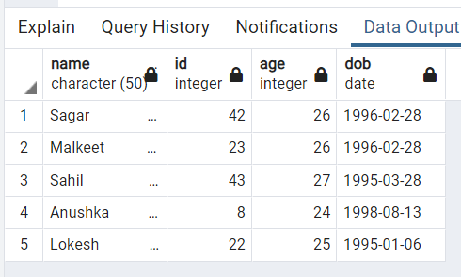

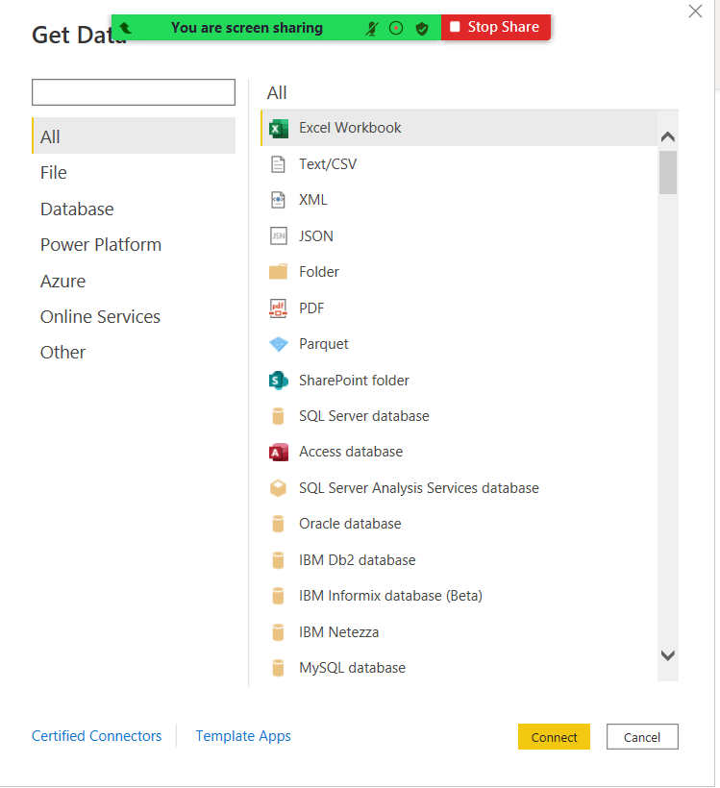

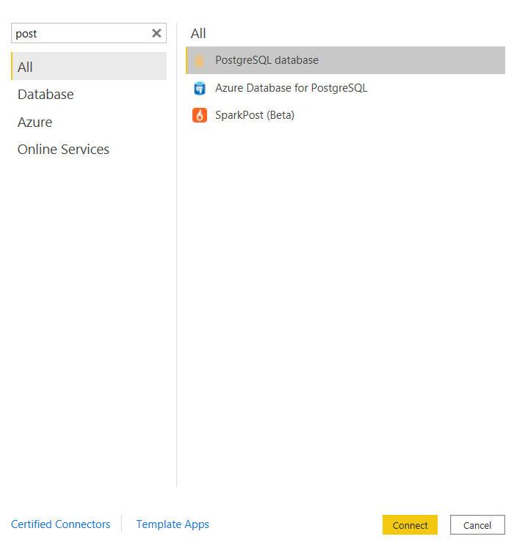

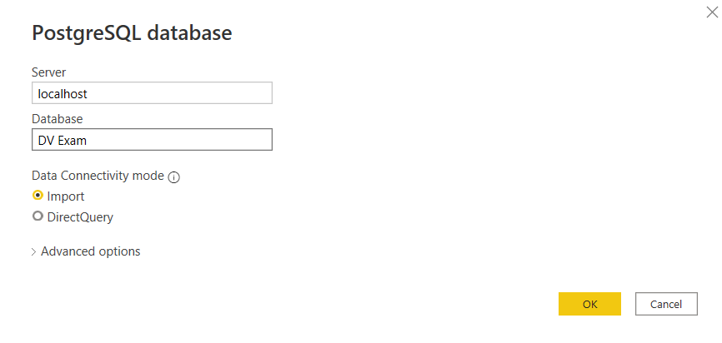

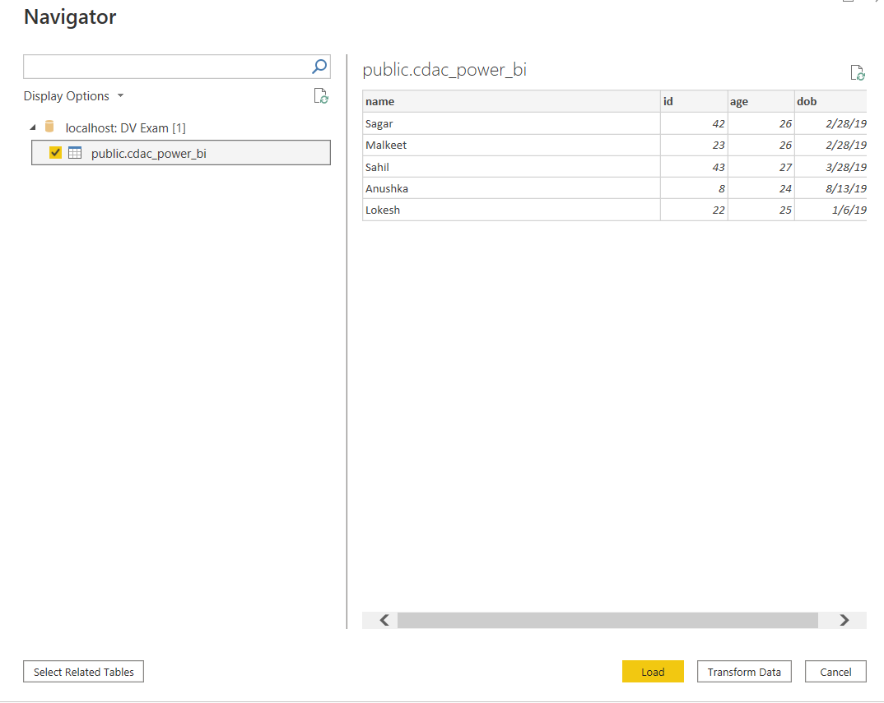

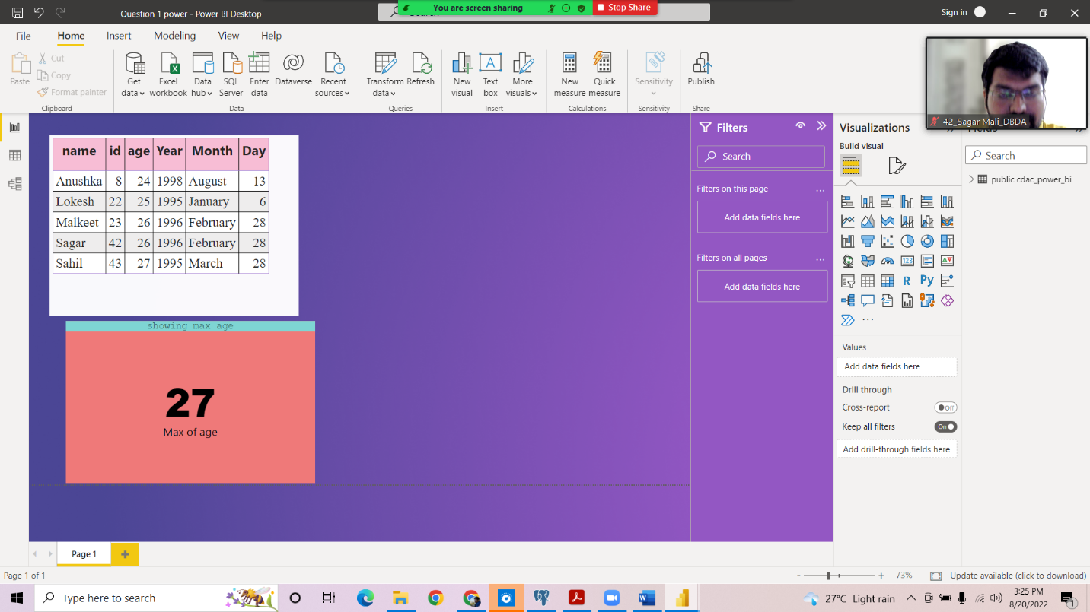

**_____________________________________________________________________**

**Question 2**

Create table chart with title , vendor,customer name,quantity,price,city

Add new calculated column naming **total_sales** which is derived from quantity * price

Create one more column naming **total_sales_2022** which is derived from quantity * price * 1.16

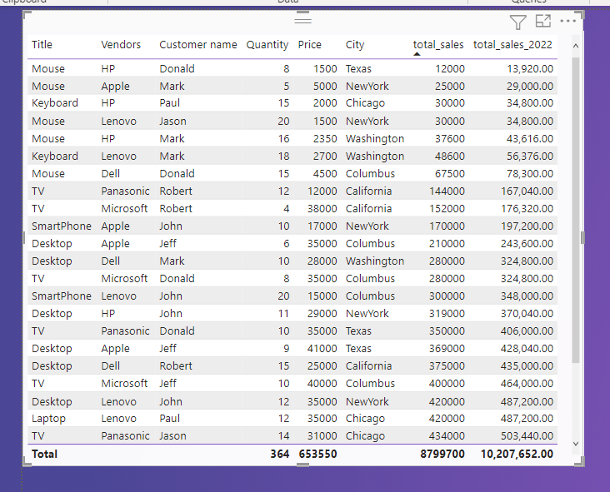

Add new measure naming max_price to get max of price column and then display every vendor max price in table chart

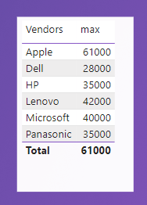

Create pie chart showing the value and percentage of quantity by vendors

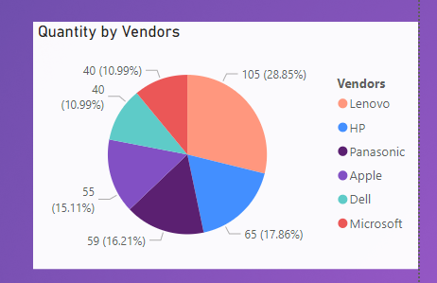

Create clustered column chart showing both **total_sales** and **total_sales_2022**

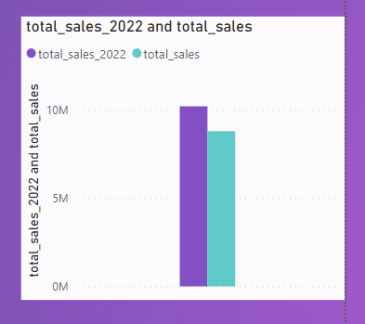

Create a slicer chart of price



Calculate avg sales and show in tile

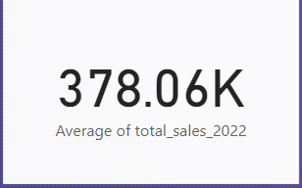

Create gauge chart with

○ value as total_sales

○ Maximum value as max of **total_sales_2022**

○ Target Value as average of total_sales

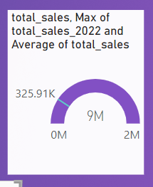

Final Dashboard

